Insane amount of plastic use that can destroy our planet!

We use a huge amount of plastic, and we all know. But what do we do with it?

An estimated 8.3 billion metric tons of ‘virgin’ plastic has been produced. This seems unimaginable when you think about it, we have been producing plastic for only a little more than 70 years.
Today, an average person in America or Europe uses 100 kg of plastic per year! That’s just one person, imagine a whole country!

You might think, what is the problem, we recycle it. Right?

Well, the amount of plastic actually getting recycled is very low.
In the ‘Peer-reviewed journal Science Advances’ they said that of the 8.3 billion metric tons that have been produced, 6.3 billion metric tons of that have become plastic waste. And of that, only 9% has been recycled. This is ridiculous, this needs to change!
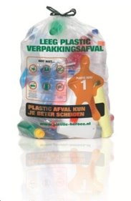
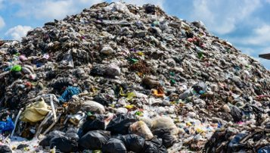
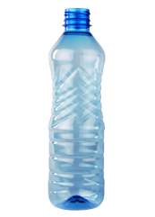

Plastic Bottle Collecting Bag So called Recycling

So if we don’t recycle all the plastic, what are we going to do? We produce and use a lot of plastic every day, and it is impossible to recycle all of that.
It even says that humans buy about 1,000,000 plastic bottles per minute in total. And only 23% of that plastic gets recycled in the United States. A lot of plastic just thrown away is plastic packaging. It plays a huge role in the plastic pollution.

We need to do something about this, because if we don’t, you don’t even know what our world will look like.
This is why we came up with a solution. It has to do with a (PET) plastic eating bacteria called Ideonella Sakaiensis. If you visit our other documents, you will find out about what Ideonella Sakaiensis is, and our solution: The Ideonella Sakaiensis Trash System. And feel free to visit our website for more!
https://istsystem.wordpress.com/

